**AniMart…**

|  |  |  |
| --- | --- | --- |
| CHAPTER NO | DESCRIPTION | PAGE NO |
| 1 | Introduction | 1-2 |
| 2 | Problem Statement | 3 |
| 3 | Objectives | 4 |
| 4 | System Analysis  4.1 Existing System  4.2 Limitations of Existing System  4.3 Proposed System | 5 |
| 5 | System Design  5.1 Architecture | 6 |
| 6 | Database Design | 7-10 |
| 7 | Module Description | 11 |
| 8 | Implementation Details | 12 |
| 9 | System Workflow | 13 |
| 10 | Testing and Results | 14-19 |
| 11 | Future Enhancement and Conclusion | 20 |

TABLE OF CONTENT

CHAPTER 1

INTRODUCTION

AniMart is a specialized e-commerce platform designed to cater to the growing community of anime enthusiasts, collectors, and fans worldwide. With the rising global popularity of anime and related merchandise, there is an increasing demand for a dedicated online marketplace that provides authentic and high-quality products. AniMart addresses this need by offering a wide range of anime-themed items such as figurines, toys, apparel, posters, collectibles, and other merchandise, all organized in a user-friendly and visually appealing interface.

The platform supports both regular users and administrators through secure registration and login functionalities. Users can browse the product catalog, search for specific items, add products to their shopping cart, save favorites in wishlists, and maintain personal collections. Administrators, on the other hand, can efficiently manage inventory, update product details, monitor orders, and handle user queries, ensuring smooth and accurate operations.

AniMart is developed using modern technologies to provide a robust and scalable solution. The backend is powered by Spring Boot, which handles business logic, security, and data processing. MySQL is used for database management, storing information related to users, products, orders, and collections. The frontend is built with HTML, CSS, and JavaScript, offering a responsive and interactive experience across various devices.

The system follows a multi-tier architecture with distinct presentation, business logic, and data layers. This modular design ensures maintainability, flexibility, and ease of future enhancements. By focusing on the unique requirements of the anime community, AniMart not only facilitates convenient online shopping but also creates an engaging and personalized user experience. This project provides valuable insights into full-stack application development, combining secure authentication, role-based access, product management, and responsive design into a cohesive and practical e-commerce solution.

CHAPTER 2

PROBLEM STATEMENT

In today’s digital age, anime has become a globally popular form of entertainment, attracting a large community of fans and collectors. However, these enthusiasts often face challenges when trying to purchase authentic anime merchandise online. General e-commerce platforms either offer a limited selection of anime-related products or mix them with other items, making it difficult for users to find specific collectibles. Additionally, such platforms often lack features tailored to anime fans, such as personal collections, wishlists, or curated product recommendations.

From a business perspective, managing an online anime merchandise store is complex without an integrated system. Administrators need an efficient way to manage inventory, update product details, track orders, and ensure accurate information is displayed to users. Manual handling of these operations can lead to errors, delays, and poor user experience.

Furthermore, security is a significant concern, as platforms must protect sensitive user information, including login credentials, personal details, and transaction data. Existing solutions often fail to provide a seamless and secure experience for both users and administrators.

AniMart aims to address these problems by creating a dedicated e-commerce platform exclusively for anime merchandise. It provides users with easy navigation, product search, wishlist and collection management, and a secure checkout process. Simultaneously, it equips administrators with tools for efficient inventory management, order tracking, and content updates. By combining functionality, usability, and security, AniMart solves the challenges faced by both users and store managers in the anime merchandise ecosystem.

CHAPTER 3

OBJECTIVES

The primary goal of AniMart is to develop a comprehensive and user-friendly e-commerce platform tailored for anime enthusiasts. The key objectives of the project include:

1. Dedicated Anime Marketplace:  
   To provide a centralized platform exclusively for anime-related merchandise, making it easier for fans to find and purchase authentic products such as figurines, toys, apparel, posters, and collectibles.
2. User Registration and Secure Login:  
   To implement secure authentication mechanisms for both users and administrators, ensuring data privacy and role-based access to different functionalities.
3. Efficient Product Management:  
   To enable administrators to manage the inventory effectively, including adding, updating, deleting, and monitoring product details, ensuring accurate and up-to-date information for users.
4. Enhanced User Experience:  
   To allow users to browse products, search for specific items, add items to a shopping cart, maintain wishlists, and manage personal collections for a personalized shopping experience.
5. Seamless Checkout Process:  
   To provide users with a smooth and secure checkout process, including cart management, order placement, and confirmation.
6. Responsive and Interactive Frontend:  
   To design a visually appealing and responsive user interface using HTML, CSS, and JavaScript, ensuring smooth operation across devices such as desktops, tablets, and smartphones.
7. Scalable and Maintainable System:  
   To develop the platform using a modular architecture with Spring Boot for the backend and MySQL for the database, allowing easy maintenance, upgrades, and scalability.
8. Security and Data Protection:  
   To ensure that all sensitive information, including user credentials and transaction data, is securely stored and processed, protecting users from unauthorized access and data breaches.
9. Facilitate Role-based Functionality:  
   To provide separate functionalities for users and administrators, ensuring that each user type can perform specific operations efficiently without interfering with other system processes.

CHAPTER 4

SYSTEM ANALYSIS

1. Introduction  
System analysis is a critical phase in software development that involves studying and understanding the requirements, functionalities, and constraints of the system to be developed. For AniMart, system analysis helps in identifying the needs of anime enthusiasts, the challenges of managing an online store, and the technical requirements for building a secure and efficient e-commerce platform.

2. Existing System Analysis  
Currently, anime merchandise is often sold through general e-commerce websites or offline stores. These platforms have several limitations:

* Limited Product Availability: Anime products are scattered across multiple sites, making it difficult for users to find specific items.
* Poor User Experience: General e-commerce sites lack anime-specific features like collections, wishlists, or curated recommendations.
* Manual Inventory Management: Administrators often rely on manual or semi-automated systems to manage stock, which can lead to errors and delays.
* Security Issues: Existing platforms may not have robust authentication or role-based access, putting user data at risk.
* Lack of Personalization: Users cannot maintain collections or track favorite items easily.

These limitations indicate the need for a dedicated and secure platform like AniMart that focuses specifically on anime merchandise.

3. Proposed System Analysis  
AniMart is designed as a full-stack web application with a modular architecture to address the shortcomings of existing systems. The proposed system includes:

* User-Friendly Interface: Allows users to browse products, search by category or keyword, and view detailed product information.
* Shopping Cart and Wishlist: Enables users to add items to a cart for purchase or save favorites in wishlists and collections for future reference.
* Admin Panel: Provides administrators with tools for CRUD operations on products, inventory management, and order tracking.
* Secure Authentication: Implements role-based login and secure data storage to protect sensitive information.
* Responsive Design: Ensures smooth operation across devices including desktops, tablets, and smartphones.
* Database Integration: Utilizes MySQL to store structured data efficiently, supporting scalability and reliability.

4. Feasibility Analysis

* Technical Feasibility: The system uses widely adopted technologies such as Spring Boot, MySQL, and frontend web technologies. Developers with knowledge of Java, SQL, and web development can implement it efficiently.
* Economic Feasibility: The system reduces operational costs by automating inventory management and order processing, minimizing manual errors, and improving sales efficiency.
* Operational Feasibility: The platform is user-friendly, providing easy navigation, search, and personalized features, ensuring a positive user experience.

5. System Requirements

* Hardware: Standard web server or local development machine with sufficient memory and storage.
* Software: Java, Spring Boot, MySQL Workbench, HTML, CSS, JavaScript, and a web browser.
* Security: Role-based access control, secure login, and protection of user data.

6. Advantages of Proposed System

* Centralized platform for anime products
* Improved user engagement with personalized collections and wishlists
* Efficient inventory and order management for administrators
* Enhanced security and reliability for users and transactions
* Scalable and maintainable architecture

CHAPTER 5

SYSTEM DESIGN

**5.1 Architecture**

AniMart follows the MVC (Model-View-Controller) pattern:

Model: JPA entities (Users, Order , category, cart).

View: Thymeleaf templates for dynamic front-end rendering.

Controller: Spring Boot REST controllers for handling requests and responses.

Database: MySQL database for persistent data storage.

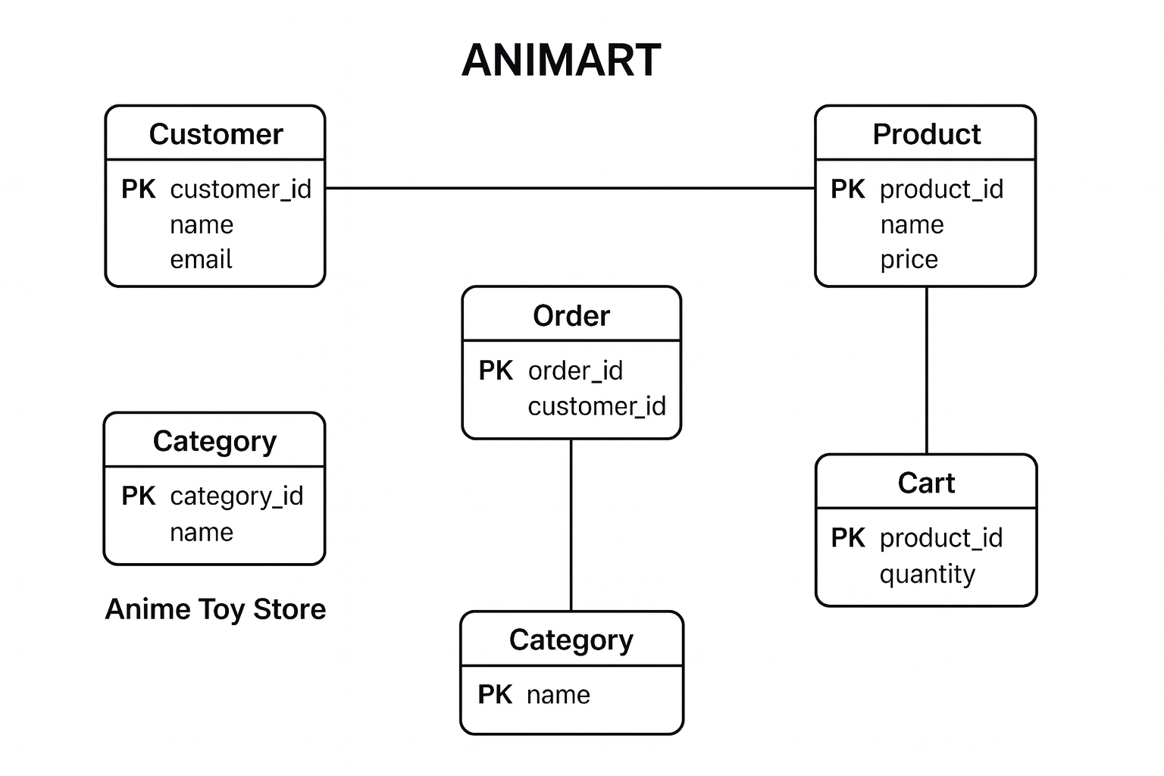

CHAPTER 6

DATABASE DESIGN

Database Name: zencure_db

Tables:

users – Stores login and account information of customers and admins..

anime_charactersStores – information about anime characters that toys are based on.

Toys – Contains product details for all anime toys available in the store.

Bookings - Records all toy orders placed by users.

booking_items-Stores details of each toy included in a booking (order items).

Ratings-Allows users to rate and review toys they purchased.

Cart-Temporary storage for items a user intends to buy (shopping cart).

Wishlist-Stores toys users mark as favorites or want to buy later.

create database animart_db;

use animart_db;

-- =======================

-- USERS TABLE

-- =======================

CREATE TABLE IF NOT EXISTS users (

id INT AUTO_INCREMENT PRIMARY KEY,

username VARCHAR(255) NOT NULL UNIQUE,

email VARCHAR(255) NOT NULL UNIQUE,

password VARCHAR(255) NOT NULL,

role VARCHAR(50) NOT NULL

);

-- =======================

-- ANIME CHARACTERS TABLE

-- =======================

CREATE TABLE IF NOT EXISTS anime_characters (

id INT AUTO_INCREMENT PRIMARY KEY,

name VARCHAR(255),

description VARCHAR(255),

image_url VARCHAR(255)

);

-- =======================

-- TOYS TABLE

-- =======================

CREATE TABLE IF NOT EXISTS toys (

id INT AUTO_INCREMENT PRIMARY KEY,

name VARCHAR(255),

description TEXT,

price DECIMAL(10,2),

stock INT,

image_url VARCHAR(255),

created_at DATETIME DEFAULT CURRENT_TIMESTAMP,

updated_at DATETIME DEFAULT CURRENT_TIMESTAMP ON UPDATE CURRENT_TIMESTAMP,

character_id INT,

FOREIGN KEY (character_id) REFERENCES anime_characters(id)

);

-- =======================

-- BOOKINGS TABLE

-- =======================

CREATE TABLE IF NOT EXISTS bookings (

id INT AUTO_INCREMENT PRIMARY KEY,

user_id INT NOT NULL,

booking_date DATETIME DEFAULT CURRENT_TIMESTAMP,

total_amount DECIMAL(10,2),

status ENUM('PENDING', 'CONFIRMED', 'CANCELLED') DEFAULT 'PENDING',

FOREIGN KEY (user_id) REFERENCES users(id)

);

-- =======================

-- BOOKING ITEMS TABLE

-- =======================

CREATE TABLE IF NOT EXISTS booking_items (

id INT AUTO_INCREMENT PRIMARY KEY,

booking_id INT NOT NULL,

toy_id INT NOT NULL,

quantity INT NOT NULL,

price DECIMAL(10,2),

FOREIGN KEY (booking_id) REFERENCES bookings(id),

FOREIGN KEY (toy_id) REFERENCES toys(id)

);

-- =======================

-- RATINGS TABLE

-- =======================

CREATE TABLE IF NOT EXISTS ratings (

id INT AUTO_INCREMENT PRIMARY KEY,

user_id INT NOT NULL,

toy_id INT NOT NULL,

rating INT NOT NULL,

comment TEXT,

created_at DATETIME DEFAULT CURRENT_TIMESTAMP,

FOREIGN KEY (user_id) REFERENCES users(id),

FOREIGN KEY (toy_id) REFERENCES toys(id)

);

-- =======================

-- CART TABLE

-- =======================

CREATE TABLE IF NOT EXISTS cart (

id INT AUTO_INCREMENT PRIMARY KEY,

user_id INT NOT NULL,

toy_id INT NOT NULL,

quantity INT DEFAULT 1,

added_at DATETIME DEFAULT CURRENT_TIMESTAMP,

FOREIGN KEY (user_id) REFERENCES users(id),

FOREIGN KEY (toy_id) REFERENCES toys(id)

);

-- =======================

-- WISHLIST (COLLECTION) TABLE

-- =======================

CREATE TABLE IF NOT EXISTS wishlist (

id INT AUTO_INCREMENT PRIMARY KEY,

user_id INT NOT NULL,

toy_id INT NOT NULL,

added_at DATETIME DEFAULT CURRENT_TIMESTAMP,

FOREIGN KEY (user_id) REFERENCES users(id),

FOREIGN KEY (toy_id) REFERENCES toys(id)

);

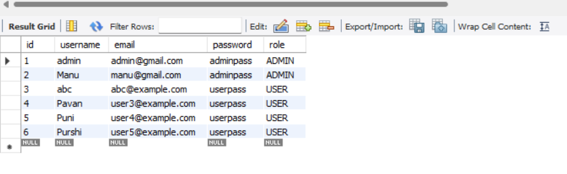

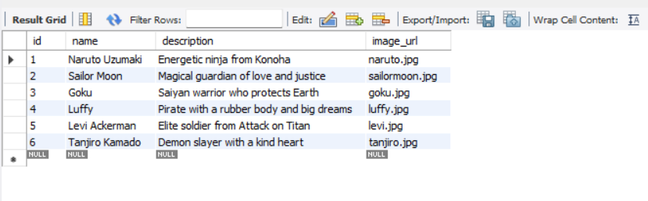

CHAPTER 7

MODULE DESCRIPTION

7.1 User Module

* User registration & login (authentication via SecurityConfig)
* Browse toys and view anime character info
* Add to cart and wishlist
* Place and track bookings/orders
* Rate and review toys
* View order and rating history

7.2 Admin Module

* Secure admin authentication and dashboard access
* Add, update, or delete toys and anime characters
* Monitor bookings and user activities
* Manage inventory (stock levels, pricing, availability)
* View ratings and user feedback

CHAPTER 8

IMPLEMENTATION DETAILS

**Backend:**

1. Built using Spring Boot and Java for handling business logic and data processing.
2. MySQL database (animart_db) stores users, toys, bookings, ratings, and wishlist data.
3. JPA (Spring Data Repository) is used for database CRUD operations.
4. Service Layer manages core logic — like booking processing, toy management, and rating calculations.
5. Controllers handle HTTP requests and link backend logic to the frontend (Thymeleaf templates).
6. Spring Security ensures authentication and role-based access (User & Admin).
7. Uses DTOs (Data Transfer Objects) for passing data between layers safely and efficiently.
8. Backend auto-loads schema and sample data using schema.sql and data.sql.

**Frontend:**

1. Designed using Thymeleaf templates integrated with Spring Boot for dynamic web pages.

2. HTML, CSS, and JavaScript used for page layout, styling, and interactivity.

3. Reusable fragments like header.html and footer.html for consistent UI.

4. Dynamic pages include:

* index.html – Home page showcasing anime toys.
* toys.html / toy-details.html – Display and detail view for toys.
* booking.html – Booking summary and checkout page.
* rating.html – Rating and review interface.
* admin-dashboard.html – Admin panel for managing toys.

5. Static resources (CSS & JS) located in /static folder:

* style.css – Handles overall site design.
* booking.js & rating.js – Handle booking and rating interactions.

6. Responsive design ensures smooth experience on desktop and mobile.

CHAPTER 9

SYSTEM WORKFLOW

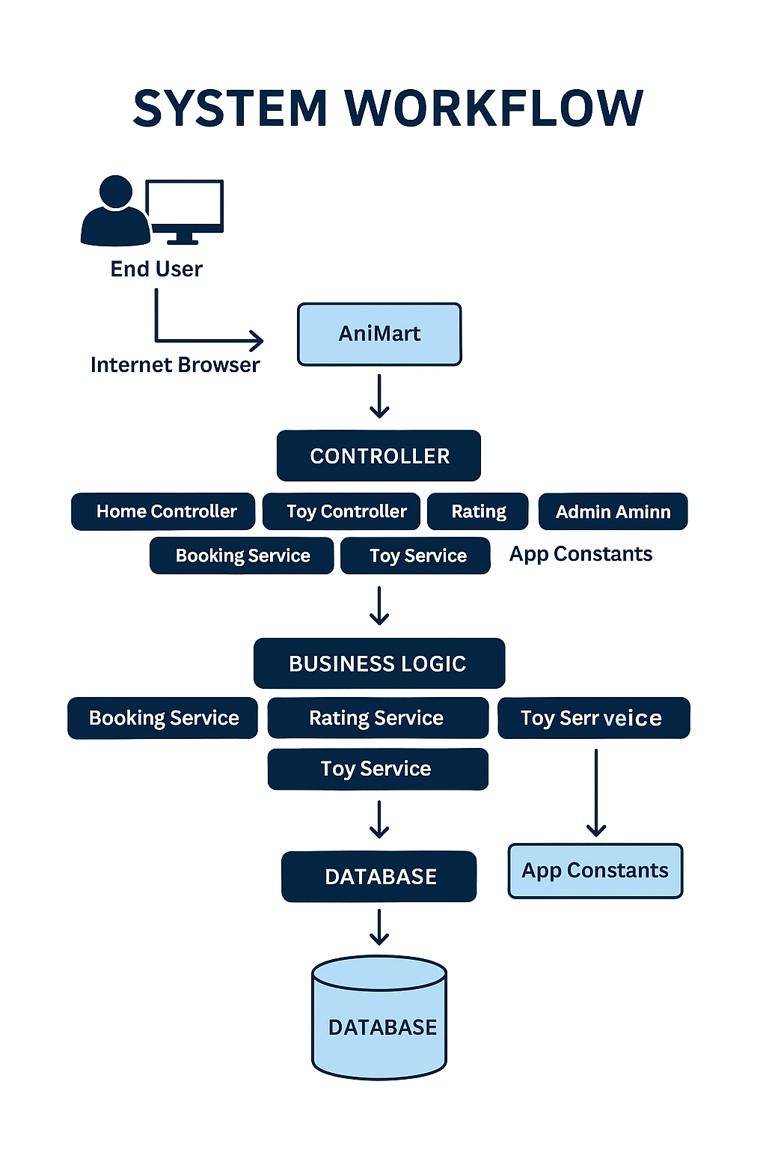

CHAPTER 10

TESTING AND RESULTS

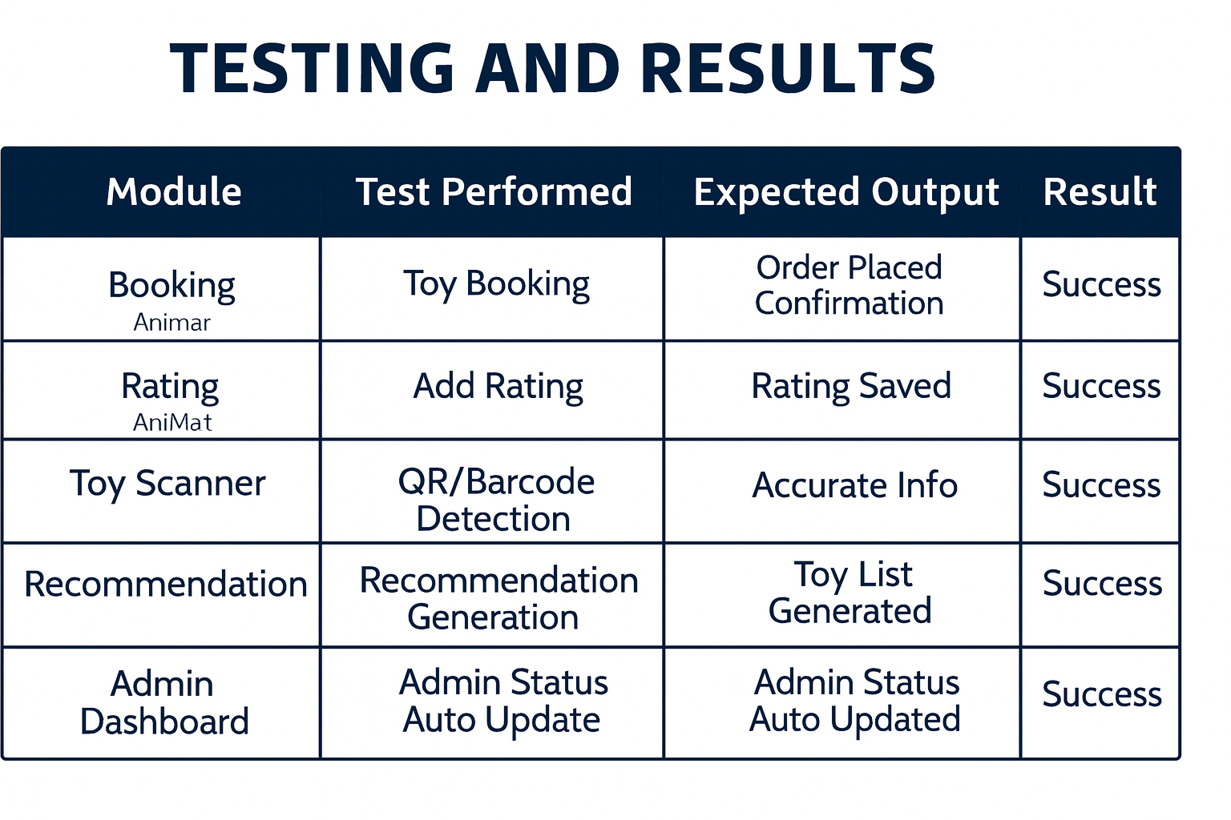

OUTPUT :

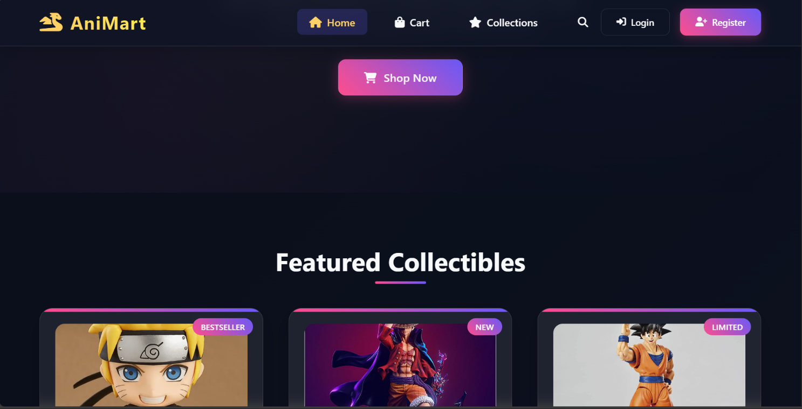

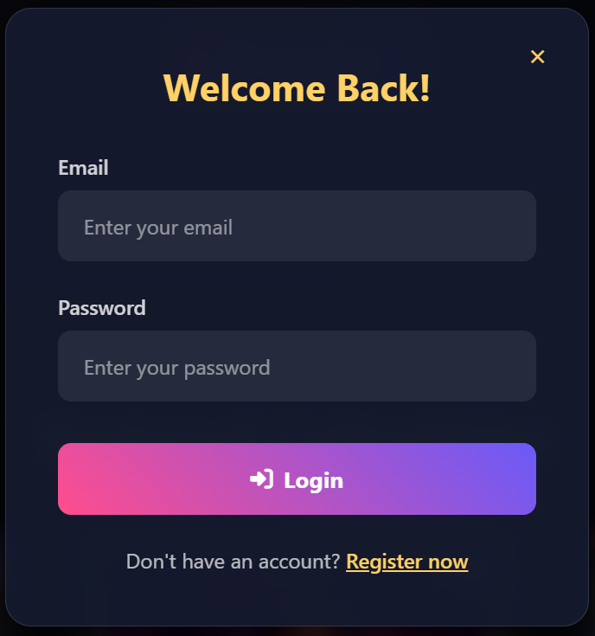

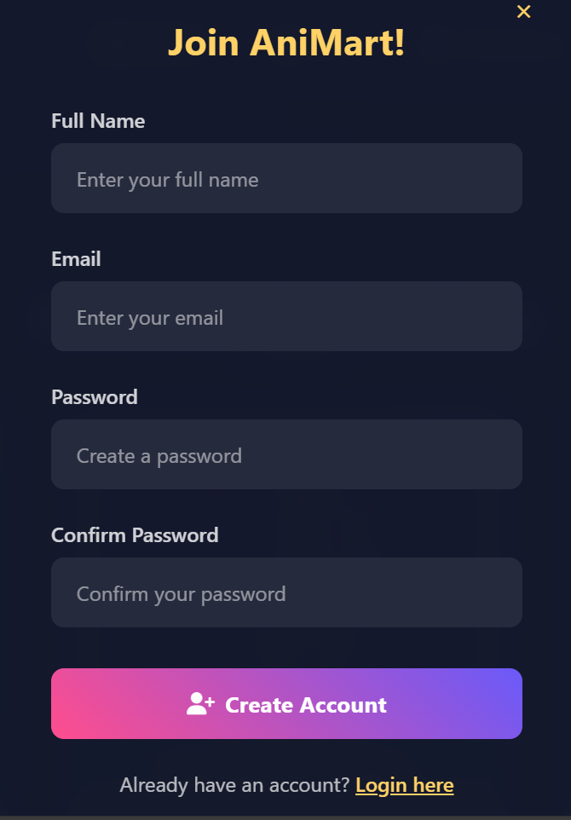

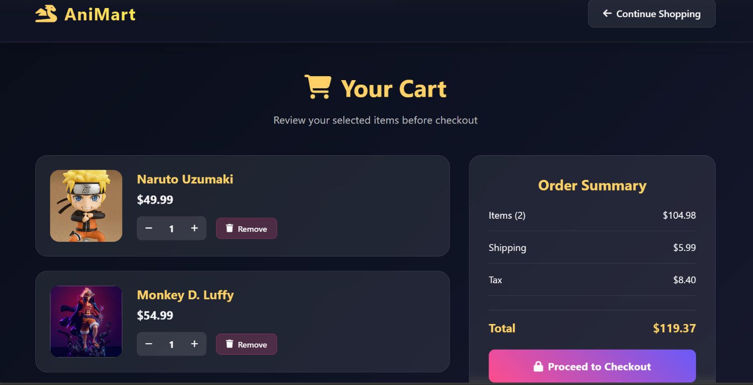

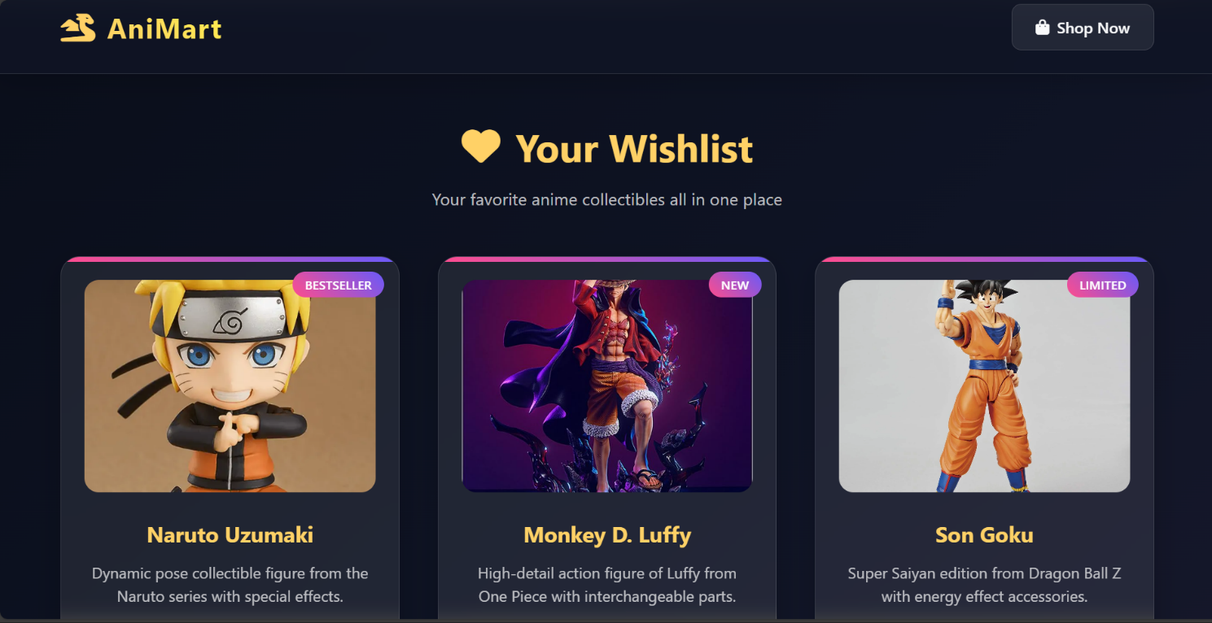

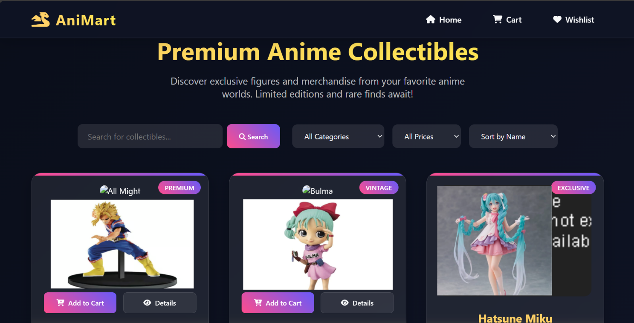

CHAPTER 11

FUTURE ENHANCEMENTS AND CONCLUSION

**Future Enhancements :**

1. Advanced Personalization

* Implement AI-driven product recommendations based on user behavior and preferences.
* Enable wishlists, favorites, and tailored homepage experiences for returning users.

2. Gamified Loyalty Program

* Introduce a points-based system where users earn rewards for purchases, reviews, and referrals.
* Offer exclusive collectibles or early access to new releases for top-tier members.

3. Augmented Reality (AR) Previews

* Let users visualize toys in their space using AR—especially useful for large figurines or display sets.

4. Community Features

* Add forums or comment sections for fans to discuss characters, collections, and share photos.
* Host monthly fan art contests or cosplay showcases to boost engagement.

5. Multilingual and Global Expansion

* Localize the site for international audiences with language and currency support.
* Partner with global shipping providers to offer reliable international delivery.

6. Mobile App Development

* Build a dedicated mobile app with push notifications for new arrivals, flash sales, and order tracking.

7. Inventory Intelligence

* Use predictive analytics to manage stock levels based on seasonal trends and pre-orders.
* Integrate supplier APIs for real-time inventory updates and restock alerts.

**Conclusion:**

AniMart is more than just a store—it's a gateway into the vibrant world of anime collectibles. With a strong foundation in backend architecture, secure authentication, and user-centric design, you're poised to build a platform that delights fans and scales with demand.

By embracing innovation, community, and strategic branding, AniMart can become a beloved destination for anime enthusiasts worldwide. Keep iterating, stay close to your users, and let your passion for anime guide the journey.